GARDEN THYME NEWSLETTER
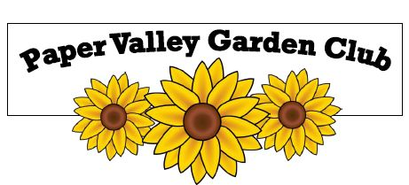
Volume 2, Issue 13 March 2022
Grow and Bloom Through Gardening and Floral Design
www.PaperValleyGardenClub.com

From Jeanne - Paper Valley Garden Club donated $200 to the Green Bay Botanical Gardens, Children’s Garden Expansion Project. Below is the link on their website where updates will be provided.
https://gbbg.org/childrens-garden-expansion-project/

From VP Mary - THE MARCH 14 MEETING will be a ZOOM MTG and the Floral committee is helping us create Floral Design at home. Please try to put together a SMALL floral design. YES, your masterpiece attempting to create a floral design that we will share with each other on ZOOM.

The background must not be larger than a 12 x 12 space. I used a 3-ring binder book to get a start on my defined space limits. Then I looked for a vase or bowl that was not too big or too small but just right.

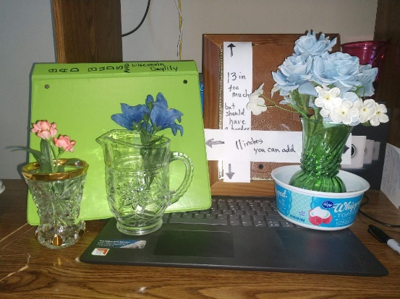

St Patrick’s day is around the corner. You can use St. Pat's decorations, pussy willows twigs, grapevines, dried hydrangeas, evergreen branches, red dogwood branches, pinecones (or parts of), little peppers. Small vegetables whole, not cut up. Trim may include twinkle lights, ribbons whatever you find. Let's give it a try.
**Elements and Principals of Floral design are at the end of this newsletter.

From Chris - It's just the beginning of March but not too early to think about the upcoming PVGC Plant Sale on Saturday May 21st.
This year it is at a new location at Claudie Zins' at 76 Cherry Court off of Memorial Drive in Appleton. (Thanks Claudia!) This is our annual fundraiser to support student scholarships, public gardens and club activities. It can also create interest in club membership to the public. This year we are going to return to have a Friday May 20th pre-sale. Soon you will see postings on our PVGC website and Facebook. Be sure to 'like' and share with friends and family to get the word out. For other advertising, we have in the past been on WHBY and WOMV radio stations, Yardsalesearch.com, Facebook Marketplace - are there any other ideas to help advertise the sale?
So, mark your calendars and look for upcoming opportunities to volunteer and supply lots of plants for this event.
Suggestions? Ideas? Contact Chris Matthias scmatt60@gmail.com
From Sue R - from attending the Garden Expo in Madison:
- Wisconsin Food Forests www.wisconsinfoodforests.com
All instructions and full information are on the website. I first heard of this from an English couple living off the grid in the UK. Fascinating.

What is a food forest?
Our favorite way of planting trees is in a food forest, an orchard that mimics a forest edge planted with edible plants. Like a natural forest, vertical layers of a food forest grow together: tall trees, small trees, shrubs, herbs, and ground covers. Tall, canopy trees grow inward from the edge. Correspondingly, smaller trees peek out from underneath the tall trees to catch the sun’s rays. Shrubs step farther out into the sunshine, along with herbs, flowers, and ground covers blanketing the sunniest edge. But aside from sequestering carbon, the best part of a food forest is that it provides you with fruits, nuts, greens, roots, and even mushrooms with little maintenance.
- Olbrich’s Home Garden Tour Featuring charming rural garden gems in Oregon, Wi
July 8 & 9, 2022. Emphasizing incorporation of native plants in garden designs to support local Wisconsin ecosystems. http://www.olbrich.org/
- INVASIVE PLANTS in Wisconsin
Find info on “Regulated Terrestrial Invasive Plants in WI” at
https://dnr.wisconsin.gov/topic/invasives/classification.html
You’ll find the plant list and within 2 clicks the photo gallery along with the regulation details on the first page.

Our calendar for 2022 so far includes:

March - Mini floral designs make & take

April - Celebrate Earth Day-Sue Mings will be planning this one

May - Wendy Jones, Education Director at Bubolz Nature Preserve will discuss why frogs have come to be known as an “indicator species” of ecosystem health

The ELEMENTS of Floral Design
☼ ☼ ☼ ☼ ☼ ☼ ☼ ☼ ☼ ☼ ☼ ☼ ☼

L - LIGHT
Effect of light on design

S - SPACE
Open areas in and around design

L – LINE
One-dimension visual path through design.

F – FORM
An object having 3 dimensions. An apple is a form, the picture of an apple is a shape
S - SIZE
Size is the element closely related to the principal scale and proportion.
P - PATTERN
Design formed by solids and spaces between them.
T – TEXTURE
Surface quality of a material

C – COLOR
How the eye sees and interprets wave length of light reflected from a surface
The Elements of Design are Tangible Ingredients in the design recipe, while the intangible Principals of Design are Directions for Combining these Ingredients into a successful design.

The PRINCIPALS of Floral Design
☼ ☼ ☼ ☼ ☼ ☼ ☼ ☼ ☼ ☼ ☼ ☼ ☼

B - BALANCE
Design must balance from top to bottom, side to side and front to back.

D - DOMINANCE
Implies subordination: for one element to be more effective, another must be less.

C - CONTRAST
Is achieved by placing opposite or unlike elements together in such a way as to utilize their differences, to create interest.

R - RHYTHM
Is achieved by the dominate visual path of line, and/or color through design, making design appear to be alive.
P - PROPORTION
Amount of plant material in relation to the size of container.
S - SCALE
Size relationship of one object in design compared to another

Original gift from Doug Jaeger. Everlasting Flowers and Gifts.

Retyped by Paper Valley Garden Club Appleton, Wisconsin

